**Assignment II**

**1. Create a Flask App**

**2. Add the Home page, About Page**

**3. Add the Bootstrap**

**4. Add the Sign in page and App the Signup Page + database connectivity**

Home Page

**index.html**

<!DOCTYPE html>

<html lang="en">

<head>

<title>Python Flask Blog App</title>

<link href="//getbootstrap.com/dist/css/bootstrap.min.css" rel="stylesheet">

<link href="//getbootstrap.com/examples/jumbotron-narrow/jumbotron-narrow.css" rel="stylesheet">

</head>

<body>

<div class="container">

<div class="header">

<nav>

<ul class="nav nav-pills pull-right">

<li role="presentation" class="active"><a href="#">Home</a>

</li>

<li role="presentation"><a href="#">Sign In</a>

</li>

<li role="presentation"><a href="showSignUp">Sign Up</a>

</li>

</ul>

</nav>

<h3 class="text-muted">Python Flask App</h3>

</div>

<div class="jumbotron">

<h1>Blog App</h1>

<p class="lead"></p>

<p><a class="btn btn-lg btn-success" href="showSignUp" role="button">Sign Up</a>

</p>

</div>

<div class="row marketing">

<div class="col-lg-6">

<h4>Blog 1</h4>

<p>No man has a good enough memory to be a successful liar - Abraham Lincoln</p>

<h4>Blog 2</h4>

<p>A successful man is one who makes more money than his wife can spend. A successful woman is one who can find such a man.</p>

<h4>Blog 3</h4>

<p>I can resist everything except temptation.</p>

<br>

<hr>

<div class="col-lg-6">

<h4>Blog 1</h4>

<p>No man has a good enough memory to be a successful liar - Abraham Lincoln</p>

<h4>Blog 2</h4>

<p>A successful man is one who makes more money than his wife can spend. A successful woman is one who can find such a man.</p>

<h4>Blog 3</h4>

<p>I can resist everything except temptation.</p>

</div>

</div>

<footer class="footer">

<p>© etaman.com 2017</p>

</footer>

</div>

</body>

**app.py**:

from flask import Flask, render_template

app = Flask(__name__)

@app.route("/")

def main():

return render_template('index.html')

if __name__ == "__main__":

app.run()

</html>

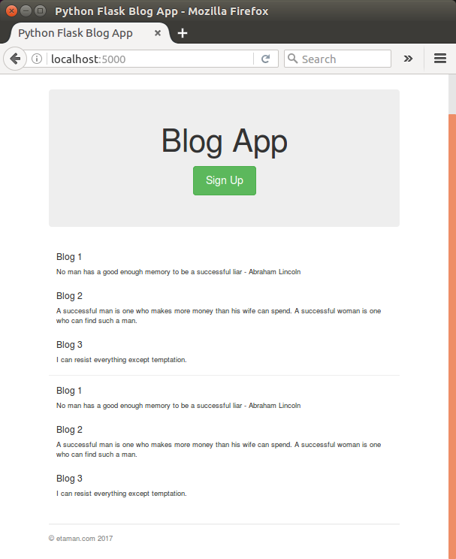

Signup

**signup.html**

<!DOCTYPE html>

<html lang="en">

<head>

<title>Python Flask Blog App</title>

<link href="//getbootstrap.com/dist/css/bootstrap.min.css" rel="stylesheet">

<link href="//getbootstrap.com/examples/jumbotron-narrow/jumbotron-narrow.css" rel="stylesheet">

<link href="/static/css/signup.css" rel="stylesheet">

</head>

<body>

<div class="container">

<div class="header">

<nav>

<ul class="nav nav-pills pull-right">

<li role="presentation" ><a href="main">Home</a></li>

<li role="presentation"><a href="#">Sign In</a></li>

<li role="presentation" class="active"><a href="#">Sign Up</a></li>

</ul>

</nav>

<img src="/static/images/Flask_Icon.png" alt="Flask_Icon.png"/>

</div>

<div class="jumbotron">

<h1>Blog App</h1>

<form class="form-signin">

<label for="inputName" class="sr-only">Name</label>

<input type="name" name="inputName" id="inputName" class="form-control" placeholder="Name" required autofocus>

<label for="inputEmail" class="sr-only">Email address</label>

<input type="email" name="inputEmail" id="inputEmail" class="form-control" placeholder="Email address" required autofocus>

<label for="inputPassword" class="sr-only">Password</label>

<input type="password" name="inputPassword" id="inputPassword" class="form-control" placeholder="Password" required>

<button id="btnSignUp" class="btn btn-lg btn-primary btn-block" type="button">Sign up</button>

</form>

</div>

<footer class="footer">

<p>©etaman.com 2017</p>

</footer>

</div>

</body>

</html>

**signup.css**

body {

padding-top: 40px;

padding-bottom: 40px;

}

.form-signin {

max-width: 330px;

padding: 15px;

margin: 0 auto;

}

.form-signin .form-signin-heading,

.form-signin .checkbox {

margin-bottom: 10px;

}

.form-signin .checkbox {

font-weight: normal;

}

.form-signin .form-control {

position: relative;

height: auto;

-webkit-box-sizing: border-box;

-moz-box-sizing: border-box;

box-sizing: border-box;

padding: 10px;

font-size: 16px;

}

.form-signin .form-control:focus {

z-index: 2;

}

.form-signin input[type="email"] {

margin-bottom: -1px;

border-bottom-right-radius: 0;

border-bottom-left-radius: 0;

}

.form-signin input[type="password"] {

margin-bottom: 10px;

border-top-left-radius: 0;

border-top-right-radius: 0;

}

